553/1
BIOLOGY
(Theory)
Paper 1
2 ¹/₂ hours
GHS
Uganda Certificate of Education
INTERNAL EXAMINATIONS, 2019
553/1 BIOLOGY
(Theory)
Paper 1
2 hours 30 minutes

INSTRUCTIONS TO CANDIDATES:
This paper consists of sections A, B, and C.
Answer all questions in Sections A and B, plus two questions in Section C.
Write the answers to Section A in the boxes provided, answers to Section B in the spaces provided, and answers to Section C in the answer booklets provided.

FOR EXAMINERS’ USE ONLY
Section |  | Marks | Examiner’s Signature & No.
A
B | No. 31
B | No. 32
B | No. 33
C | No.
C | No.
TOTAL

SECTION A (30 marks)

- What is the process whereby small molecules, such as glucose and urea, pass from the blood into the nephron at the Bowman's capsule?

- Active transport
- Diffusion
- Selective reabsorption
- Ultrafiltration

- Which of the following correctly describes the changes that take place when a person looks at a distant object?
Ciliary muscle | Suspensory ligament | Shape of lens
- Contracts | Becomes less taut | Becomes more convex
- Contracts | Becomes taut | Becomes less convex
- Relaxes | Becomes less taut | Becomes less convex
- Relaxes | Becomes taut | Becomes less convex

- The stomach is considered as an organ, because…
- it consists of a group of cells working together to digest food
- it consists of different tissues working together to digest food
- it is a basic unit of life
- it produces digestive enzymes to digest food

- Excess amino acids are toxic to the human body, and must be deaminated. Excess amino acids are deaminated in the…
- Ileum
- large intestine
- liver
- stomach
- The first step in the test for starch in a leaf, is to place the leaf in boiling water for about 5 minutes. What is the reason for this step?
- To denature all enzymes in the leaf
- To make the leaf softer so that it is easier to test for starch
- To remove air in the leaf
- To remove chlorophyll from the leaf

- The following events occurs during inspiration in a man, except:
- External intercostal muscles contracts
- Internal intercostal muscles contracts
- Diaphragm contracts
- Internal intercostal muscles relaxes

- Which one of the following correctly represents variation of rate of transpiration with humidity?
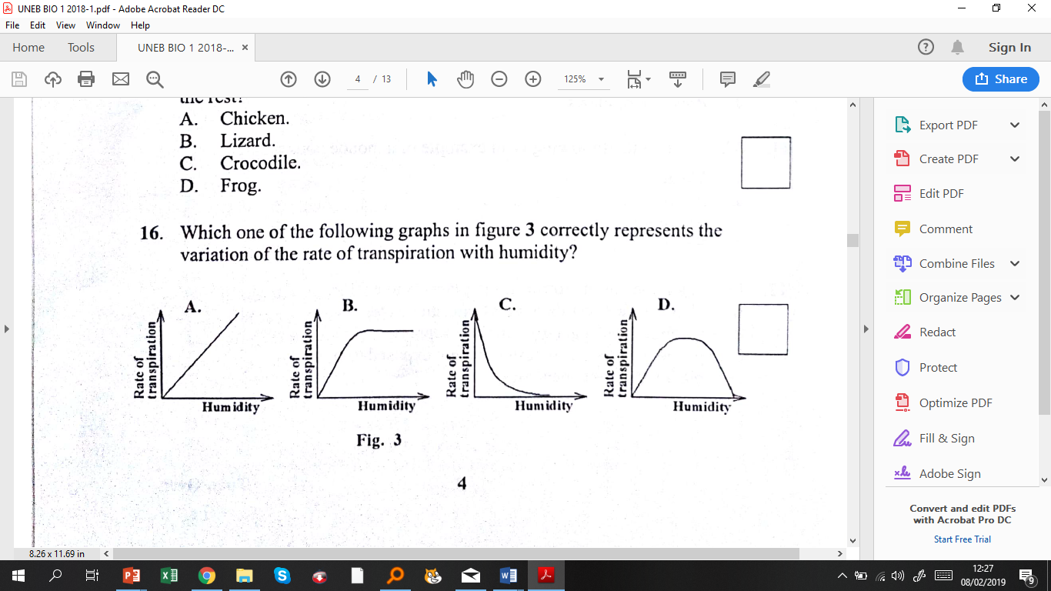
- Study the investigation in the figure below.
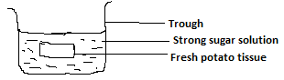
Which of the followings describe what happens when the experiment is allowed to run for 1 hour?
- Tissue loses water. The level of sugar solution in the trough rises.
- Sugar diffuses into the tissue. The sugar level in the trough reduces.
- Tissue decreases in size. Concentration of sugar solution reduces.
- Both the size of the tissue and the level of solution remain the same.
- Which organisms convert ammonium compounds to nitrates?
- decomposing bacteria
- nitrifying bacteria
- decomposing fungi
- nitrogen-fixing bacteria

- The following constitute both blood and lymph except
- Water C. Dissolved food
- Lymphocytes D. Erythrocytes

- Which blood vessel transports absorbed food substances to the liver?
- Hepatic artery
- Hepatic vein
- Hepatic portal vein
- Pulmonary artery
- The process by which water enters the root hair cell is called
- active transport
- osmosis
- diffusion
- phagocytosis

- Which conditions would cause a plant to wilt most rapidly?
- High humidity, high temperature, high wind speed
- High humidity, low temperature, high wind speed
- Low humidity, high temperature, high wind speed
- Low humidity, low temperature, high wind speed

- Which of the following correctly describes the processes occurring in a person's skin when he takes a cold shower?
- The arterioles constrict, and sweat glands are more active.
- The arterioles constrict, and sweat glands are less active.
- The arterioles dilate, and sweat glands are more active.
- The arterioles dilate, and sweat glands are less active.

- To which phylum do liver flukes belong?
- Mollusca
- Platyhelminthes
- Annelida
- Arthropoda

- What are the final products of anaerobic respiration in plants?
- Carbon dioxide, water and energy
- Carbon dioxide, water and alcohol
- Carbon dioxide, alcohol and energy
- Carbon dioxide and alcohol

- What is the percentage of humus in soil if the following results were obtained in an experiment:
- Mass of empty crucible = 22g
- Mass of soil + crucible before drying = 50g
- Mass of soil + crucible after drying = 46g
- Mass of soil + crucible after heating to red hot = 44g

- 25%
- 7.14
- 21.4%
- 8.33%

- The following are components of axial skeleton of mammals, except:

- Sternum
- Vertebrae
- Ribs
- humerus

- Which one of these insects does not lay eggs in its lifecycle?

  - Bee
  - Grasshopper
  - Tsetse fly
  - Housefly

- In a mammalian heart, the left ventricle is more muscular than the right because it
- Pumps a lot of blood to the lungs.
- Pumps blood to all parts of the body.
- Receives blood from all parts of the body.
- Receives more blood.

- Which of the following are end products from digestion of cane sugar?

- Sucrose and maltose.
- Glucose and fructose.
- Maltose and galactose.
- Fructose and galactose

- A soil with poor water retention ability has
  - Low capillarity.
  - Small particles.
  - Poor aeration.
  - Poor drainage.
- Which one of the following is a method for controlling tapeworms
  - Use of insecticides.
  - Chlorination of water.
  - Drainage of stagnant water
  - Proper disposal of seawage.
- Which one of the following factors favour cross pollination?
  - Stamens and carpels maturing at the same time.
  - Flowers remaining closed after maturation.
  - Stamens being situated below the stigma.
  - Style being shorter than the filament.
- Which ones of the following hormones are both produced by gonads
  - Testosterone and adrenaline.
  - Follicle stimulating hormone and thyroxin.
  - Progesterone and oestrogen.
  - Anti- diuretic hormone and oestrogen.
- Which one of the following are products of aerobic and anaerobic respiration
  - Water and carbon dioxide.
  - Carbon dioxide and oxygen.
  - Ethanol and water.
  - Carbon dioxide and lactic acid.

- Which one of the following is an example of a monoecious plant?
  - Maize.
  - Pawpaw.
  - Pineapple.
  - Bean.
- The importance of phototropism in plants is to enable?
  - Plants grow towards mineral salts and water.
  - Climbing plants get grip on their support.
  - Plants in shade grow faster and get exposed to light.
  - Plant roots gain anchorage.
- Which one of the following organisms would have its body temperature remain constant as the environmental temperatures change?
  - Snake.
  - Bird.
  - Toad.
  - Snail.
- Which one of the following sets consists of only dry dehiscent fruits
  - Achne, sypsela, nut.
  - Caryopsis, legume. Capsule.
  - Capsule, follicle, legume.
  - Schizocarp, capsule, caryopsis

SECTION B (40 marks)
- The figure below shows the amount of carbon dioxide in the air in a forest over a period of 24 hours measured during a sunny day.
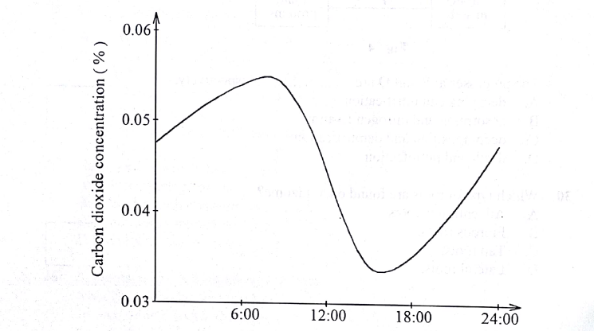

- Explain the changes in carbon dioxide concentration.
- Between 8.00 hours to 16.00 hours. (4 marks)
……………………………………………………………………………………………………………………………………………………………………………………………………………………………………………………………………………………………………………………………………………………………....………………………………………………………………………………………………………………………………………………………………………………………………………………………………………………………………………………………………………………………………………………………………………………………………………

- Between 16:00 hours and 24:00 hours (04 hours)

……………………………………………………………………………………………………………………………………………………………………………………………………………………………………………………………………………………………………………………………………………………………....………………………………………………………………………………………………………………………………………………………………………………………………………………………………………………………………………………………………………………………………………………………………………………………………………………………………
- (i) At what time was carbon dioxide highest?
……………………………………………………………………………………………
- Why?
…………………………………………………………………………………………………………………………………………………………………………………………………………………………………………………………………………………………………………………………………………………………………………………………………………………………………………………………………………………………………………………………………………………………………………………………………
- (i) At what time was carbon dioxide lowest

………………………………………………………………………………………
(ii)Why?
…………………………………………………………………………………………………………………………………………………………………………………………………………………………………………………………………………………………………………………………………………………………………………………………………………………………………………………………………………………………………………………………………………………………………………………………………

- (i) On the same graph draw a sketch to show the variation in the concentration of carbon dioxide over the same period of time if the measurement was carried out during a cloudy day.
- Explain the variation in carbon dioxide concentration in your sketch compared to the original graph. (03 marks)
………………………………………………………………………………………………………………………………………………………………………………………………………………………………………………………………………………………………………………………………………………………………………………………………………………………………………………………………………………………………………………………………………………………………………………………………………………………………………....................................................................
- The figure below shows part of the mammalian circulatory system

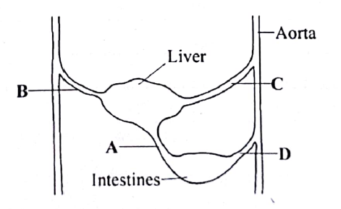
(a) Name the parts labelled A, B, C and D (2 marks)
A…………………………………………………………………….
B………………………………………………………………………
C………………………………………………………………………
D………………………………………………………………………
(b) using arrows, show on the diagram the direction of blood flow in the blood vessels labelled A and B. (1 mark)
(c) State any three differences in composition of blood flowing in A and B (3 marks)
…………………………………………………………………………………………………………………………………………………………………………………………………………………………………………………………………………………………………………………………………………………………………………………………………………………………………………………………………………………
(d). Explain the changes in the composition of glucose in A and B (2 marks)
………………………………………………………………………………………………………………………………………………………………………………………………………………………………………………………………………………………………………………………………………………………………………………………………………………………………………………………………………………………………
- How is blood vessel labelled A structurally adapted to perform its function? (2 marks)
……………………………………………………………………………………………………………………………………………………………………………………………………………………………………………………………………….........................................................................................................................................

- (a) what are tropisms (1 mark)
…………………………………………………………………………………………………………………………………………………………………………………………
(b)Give any three importance of tropisms in plants (6 marks)
………………………………………………………………………………………………………………………………………………………………………………………………………………………………………………………………………………………………………………………………………………………………………………………………………………………………………………………………………………………………………………………………………………………………………………………………………………………………………………………………………………………………………………………………………………………………………………………………………………………………………….............................................
(c) Explain how auxin hormone concentration affects growth of roots (2 marks)

…………………………………………………………………………………………………………………………………………………………………………………………………………...................................................................................................................................................................................................................................................................................................................

SECTION C (Attempt only two questions)
- (a) What is transpiration (01 mark)
(b) Describe an experiment to show that the lower part of a leaf on a plant losses water faster than the upper part by transpiration . (09 marks)
(c) In what ways is transpiration,
(i) Advantageous to plants (04 marks)
(ii) Disadvantageous to plants (01 marks)
- (a) Give three importance of photosynthesis in nature (3 marks)
      - How is a leaf adapted for the functions of photosynthesis (6 marks)
      - Discuss any three factors that affect the rate of photosynthesis (6 marks)

- (a)What is the importance of gaseous exchange in animals (2 marks)
(b). Describe the process of exhalation in humans (05 marks)
(c) Outline the differences between exhaled and inhaled air in humans (03 marks)
(d) Explain how the lungs are efficient respiratory surfaces (05 marks)

END

